“Technology Transforming the Experience of Care in the Home” Summit
Directions to Leavey Center Parking Garage and Rafik B. Hariri Building

- The following address can be used with mapping software, or as a taxi destination: 3800 Reservoir Road, NW, Washington, DC 20007.
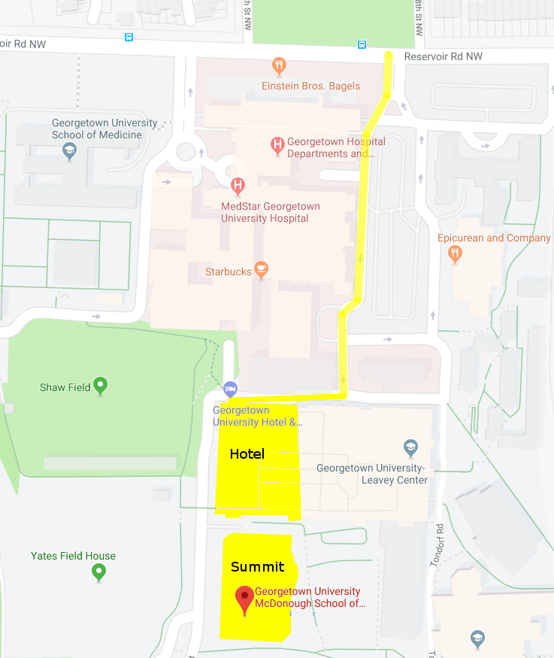
- From Reservoir Road NW, take entrance number 1 into the Georgetown University Hospital complex. Please note that morning traffic around Georgetown can be heavy. Try to allow extra time to arrive at the Summit on time.
- Follow the entrance lane straight until the road ends.
- If parking: Follow the signs for the Leavey Center Garage. From the garage, follow signs to reach the Hariri building.
- If dropping off at the Hotel entrance: Enter the hotel front door and proceed through the building, following signs to reach the Hariri building.
- Inside the Hariri building, take the elevator to the fourth floor. Fisher Colloquium is located over the bridge.

For detailed information regarding ADA accessibility on campus, see https://georgetown.app.box.com/s/yugeway8lrq8zh3moljvixzq2qlnf480.

