“Technology Transforming the Experience of Care in the Home” Summit
Hotel Recommendations

- Georgetown University Hotel and Conference Center (Located on campus)
3800 Reservoir Rd NW, Washington, DC 20057
(202) 687-3200
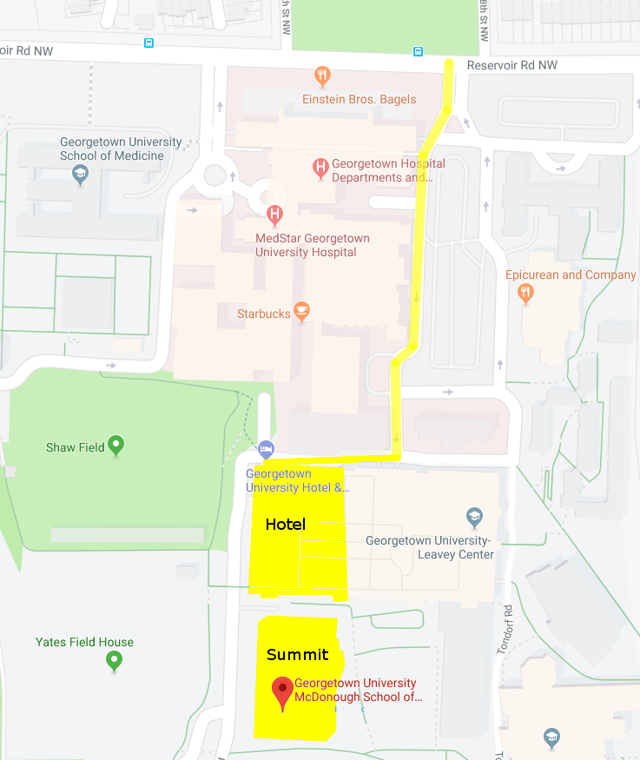
Georgetown University Hotel & Conference Center is the preferred hotel for Georgetown University, located right on the university’s campus. The hotel is located next door to the McDonough School of Business, where the Tech Summit will be held.
Rooms are currently $259 per night for April 8 and 9.
If you plan to stay at the Georgetown University hotel, we recommend you make reservations quickly to ensure room availability.
We have also provided this map of where the hotel and summit are located on campus, and the best route to reach them. For your convenience, please approach campus from Reservoir Road NW.

- Holiday Inn, Rosslyn at the Key Bridge
1900 N Fort Myer Drive
Arlington, VA 22209
The Holiday Inn, Rosslyn at the Key Bridge is located in Arlington, VA, a 10-minute taxi ride from Georgetown’s campus. Rooms are currently $170 per night for April 8 and 9.

- Key Bridge Marriott
1401 Lee Highway
Arlington, Virginia 22209
The Key Bridge Marriott, in Arlington, VA, is roughly 10 minutes from Georgetown’s campus by taxi. Rooms are currently $197 per night for April 8 and 9.

- The Kimpton at Glover Park
2505 Wisconsin Ave NW
Washington, DC 20007
The Kimpton at Glover Park, located in Georgetown, is roughly 6 minutes from campus by taxi. Rooms are currently $215 per night for April 8 and 9.

- The Graham Georgetown
1075 Thomas Jefferson Street NW
Washington, DC 20007
The Graham Georgetown is located 11 minutes from campus by taxi. Rooms are currently $389 per night for April 8 and 9.

- The Ritz-Carlton Hotels of Washington, D.C.
1150 22nd Street NW
Washington, DC 20037
The Ritz-Carlton is located 15 minutes from Georgetown’s campus by taxi. Rooms are currently $399 per night for April 8 and 9.

If you need any additional details, please contact Jared Hite at jhite@ltqa.org.

