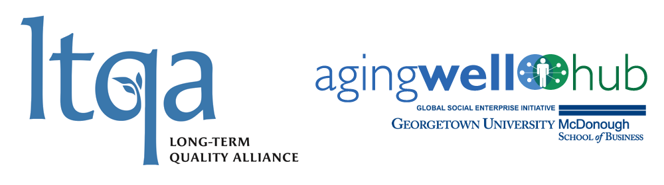
Technology Summit
Transforming the Experience of Care in the Home:
Opportunities and Challenges

April 9 and 10, 2018
Fisher Colloquium, McDonough School of Business
Georgetown University

Monday, April 9
8:00 am Registration

8:30 Welcome
Carol Raphael, Chair, LTQA
Bill Novelli, AgingWell Hub

8:45 How the Summit Will Work
Liddy Manson, AgingWell Hub
Larry Atkins, Executive Director, LTQA

9:00 Keynote Address:
“Holistic Care and the Imperative and Opportunity for Transformation of In-Home Support”
Dr. Vivek Garg, Chief Medical Officer, New Markets and Business Development, CareMore Health Plan.

9:45 Panel One: Technologies that Promote Independence
- Moderator: Mark Hanson – George Washington University
- Consumer/Provider/Plan Representatives
  - Gail Hunt – National Alliance for Caregiving
  - Kelly Buckland – NCIL
  - Barbara Merrill – ANCOR
  - Chris Palmieri – CCA
- Innovators/Entrepreneurs
  - Katie Schmidt – formerly, Homecare Advantage
  - Lainie Muller – Alarm.com
  - Todd Walrath – Homecare.com
  - Jake Swanton – Lyft

11:30 Roundtable Discussion

12:30 Lunch
“The Future of Assistive Technology and its Role in Transforming the Experience of Care in the Home”
Dr. Rory Cooper, Director, Human Engineering Research Labs, University of Pittsburgh

2:00 Panel Two: Technologies that Enable Cross-Sector Collaboration
- Moderator: Brittany Weinberg – Aging 2.0
- Consumer/Provider/Plan Representatives
  - Anne Tumlinson – Daughterhood.org
  - John Tschida – AUCD
  - Merrill Friedman – Anthem
  - SEIU (Invited)
- Innovators/Entrepreneurs
  - Honor (Invited)
  - Lois Simon – Vela (SeniorLink)
  - Dirk Peters – CareGeneral
  - Geoffrey Nudd – ClearCare

3:30 Roundtable Discussion

5:15 Reception

Tuesday, April 10
8:30 Coffee and Pastries

9:00 Keynote Address:
“Disrupting Home Care – The Investor View of Technology”
Nancy Ann DeParle – interviewed by Liddy Manson

9:45 Panel Three: Virtual Delivery Systems
- Moderator: Charlene Frizzera – Leavitt Partners
- Consumer/Provider/Plan Representatives
  - Abe Rafi – The ARC
  - Sarah Triano – Centene
  - Henry Claypool – Claypool Consulting
- Innovators/Entrepreneurs
  - Pete Celano – MedStar
  - Adam Barth – Avizia
  - Brian Yarnell – Blue Stream Health

11:30 Roundtable Discussion

12:30 Lunch and Closing Roundtables
Meeting Big Needs and Transforming LTSS Through Technology – What Could Accelerate Change?

1:30 Summit Closing – What Next?

